**Lab 03: Assignment: Ping Utility Analysis**

**Vishwas S**

**2201CS78**

1. Purpose of ping:

The ping utility is used to test the reachability of a host on an IP network. It also measures the round-trip time for messages sent from the source to the destination and back.

Basic syntax:  **ping [options] destination**

destination can be an IP address or a hostname.

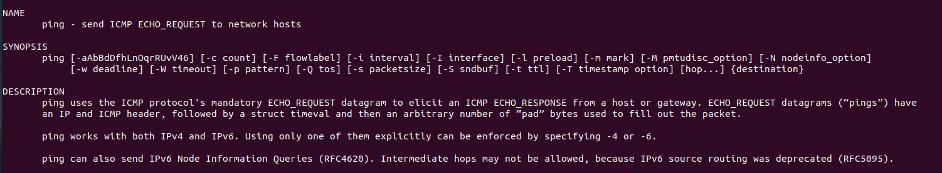

Examples:

To test connectivity to a website: ping [google.com](http://www.google.com)

To test connectivity to a local host: ping 127.0.0.1



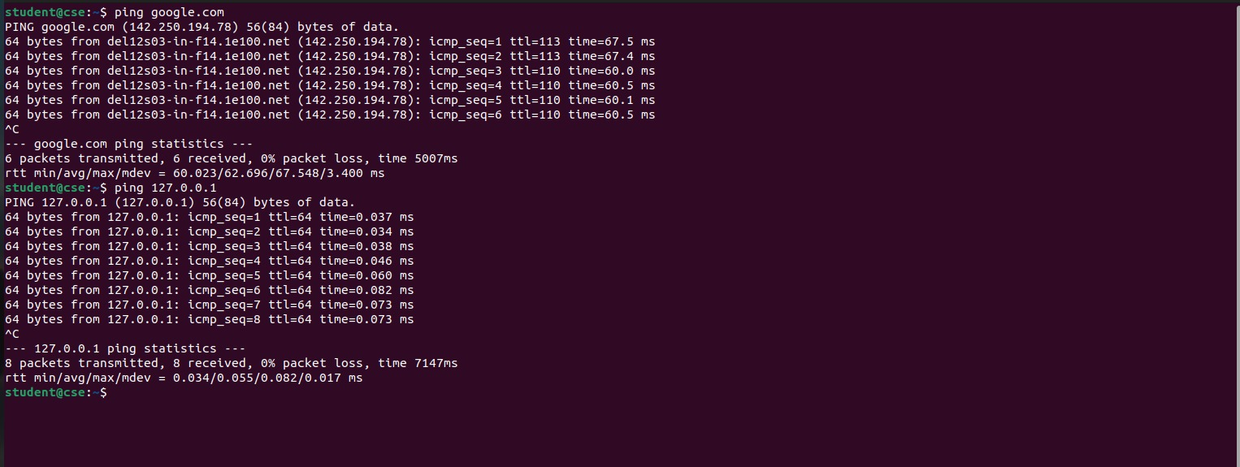

Analysis:

ping to a website:

**PING line**: Shows the target being pinged and the size of the ICMP packets.

**64 bytes from...**: Indicates a successful ping response.

**icmp_seq**: Sequence number of the ping request.

**ttl**: Time-To-Live value, which limits the packet's lifetime.

**time**: Round-trip time for the packet.

The first packet was received with a round-trip time (RTT) of 67.5 ms.

**Ping statistics**:

**packets transmitted**: Number of ICMP requests sent.

**packets received**: Number of ICMP replies received.

**packet loss**: Percentage of lost packets.

6 packets transmitted, 6 received, 0% packet loss, time 5007 ms: No packets were lost during the session.

**round-trip**: Min, average, max, and standard deviation of the round-trip times.

Ping to local host:

Similar to the previous output, but with a much faster RTT since it's a local host.

1. **-c** (count): Specify the number of packets to send. Example: **ping -c 5 google.com**

**-s** (size): Specify the size of the packets to send. Example: **ping -s 100 google.com**

**-t** (ttl): Specify the Time-To-Live (TTL) of the packets. Example: **ping -t 10 google.com**

**-W** (deadline): Specify the timeout for the ping command. Example: **ping -W 5 google.com**

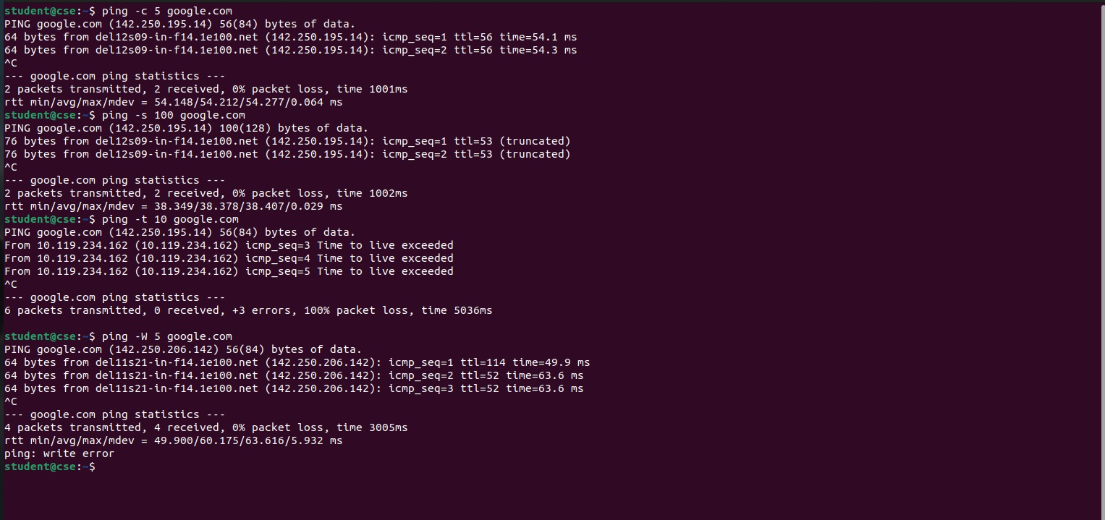

4.

Scenario: A user reports that they cannot access a website. To troubleshoot, we can use ping to test connectivity to the website.

Steps:

1. Ping the website's IP address to test connectivity.
2. Use the **-c** option to send a specified number of packets.
3. Use the **-t** option to specify a lower TTL to test for routing issues.
4. Use the **-W** option to specify a timeout to test for slow network speeds.

Example: **ping -c 10 -t 10 -W 5 google.com**

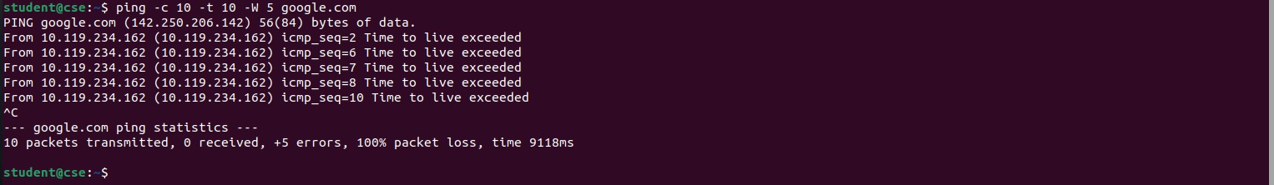

1. Code:

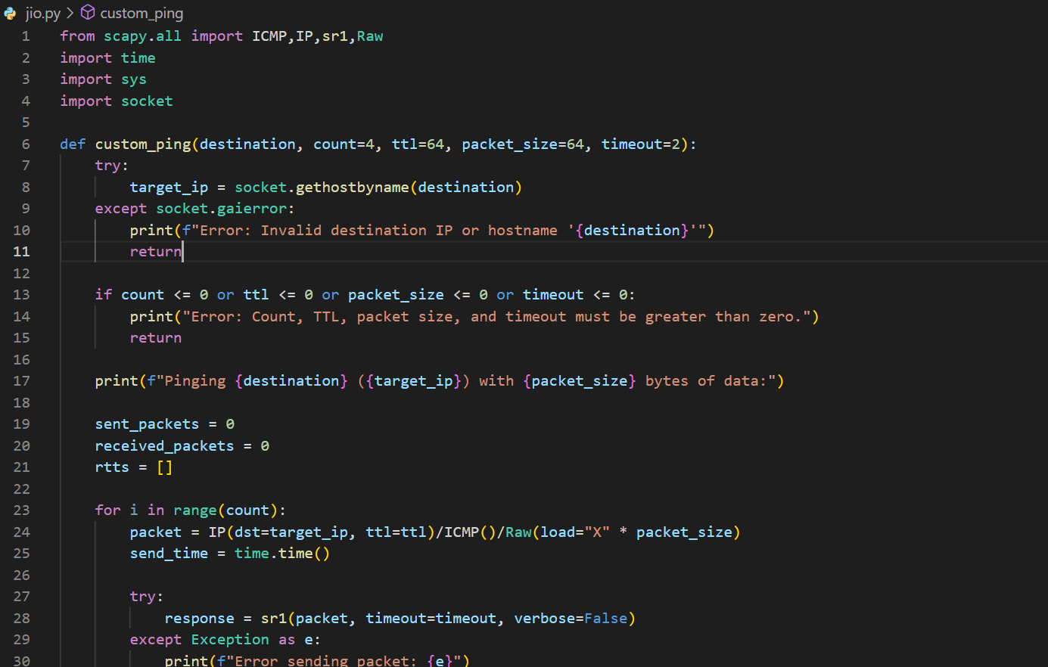

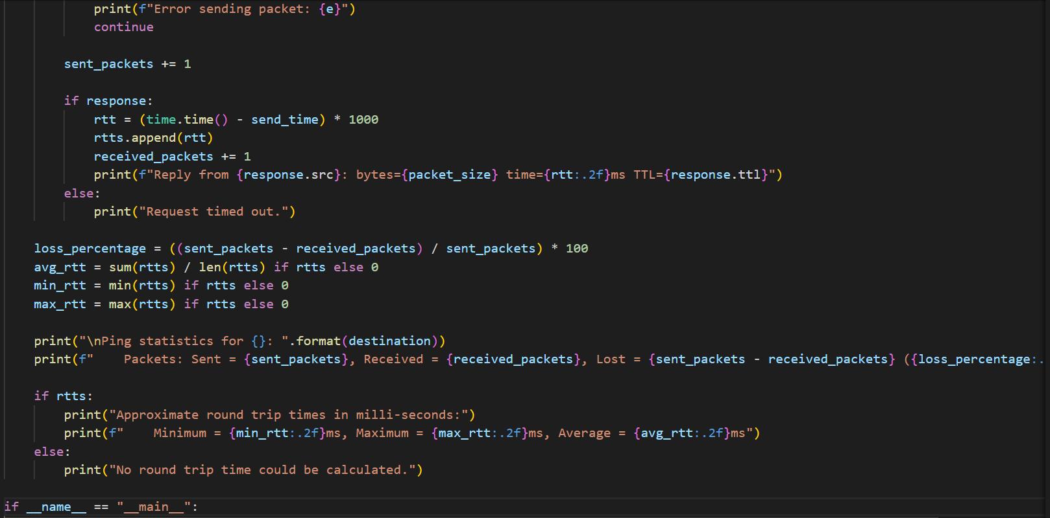

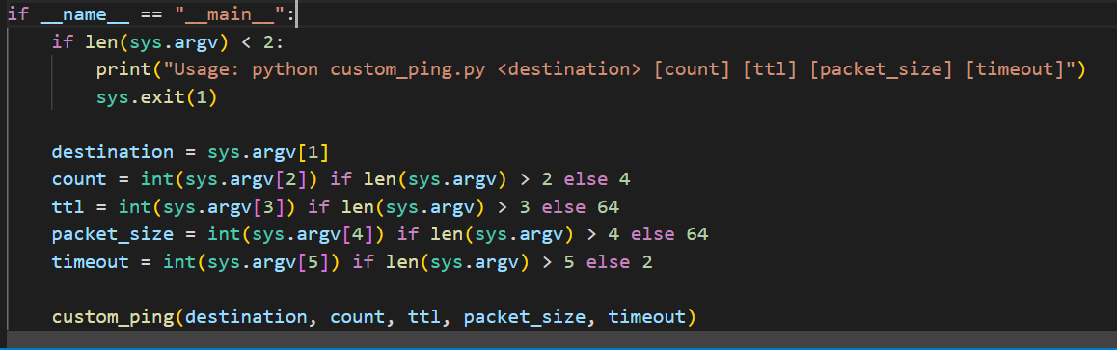

Output : 